**Guidance link:** [https://join.globalfundforwomen.org/a/donate?_gl=1*vit40j*_ga*MTU1MDkyNTM5My4xNjg0MTgwNjc0*_ga_WGPQPN3LNW*MTY4ODMzODM5MC4zMC4xLjE2ODgzMzg0OTYuMC4wLjA](https://join.globalfundforwomen.org/a/donate?_gl=1*vit40j*_ga*MTU1MDkyNTM5My4xNjg0MTgwNjc0*_ga_WGPQPN3LNW*MTY4ODMzODM5MC4zMC4xLjE2ODgzMzg0OTYuMC4wLjA).

With the option to add one outreach image

**\*Please link the donate page at the bottom of the page.**

All it takes to change the world are two hands joined together, united by will. With your grains of sand, we can make a pleasant land. Be the impact our world needs and help 200+ women start a business today.

We have two donation options, depending on where you are located.

Donate through the links:

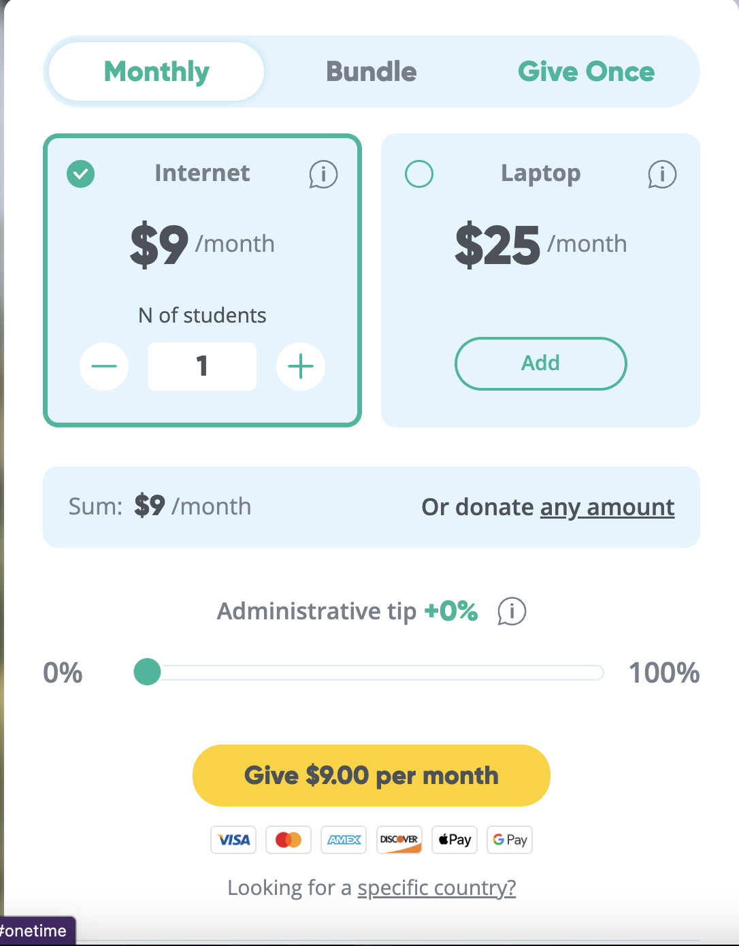

Administrative tip

Donate through bank transfer:

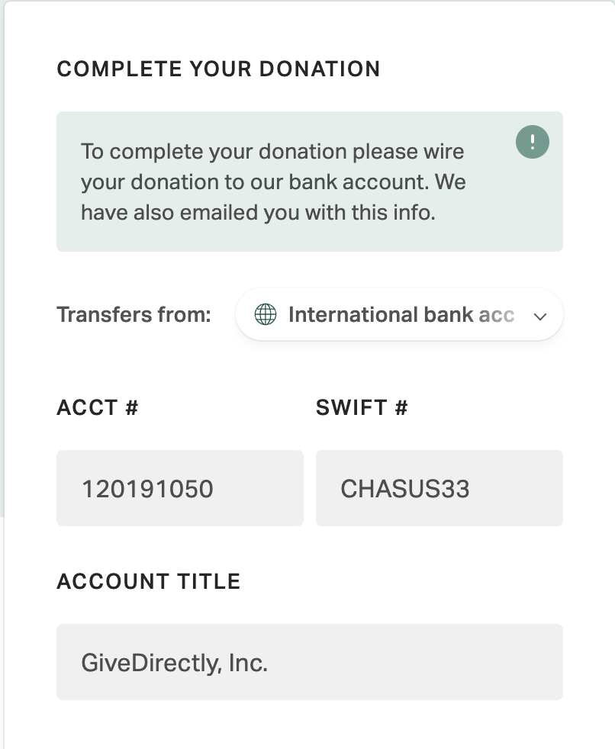

If you prefer to donate via a bank transfer, please find below our bank details:

* a warning icon stating that - “This account can only accept domestic Naira donations and not international currencies. Please use our donation link for international donations.”

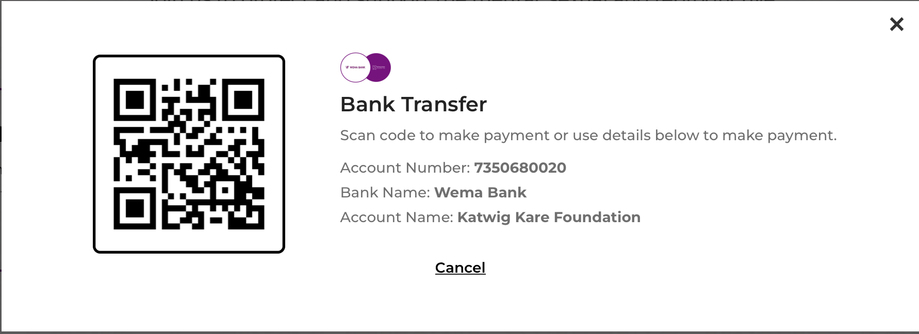

*barcode included

**Donation FAQs**

What if i have a problem donating?

* Please send us an email on [info@renbiwomen.org](mailto:info@renbiwomen.org) and we will be happy to assist you.

Can i donate clothes, food and other items to Renbi women?

* We are grateful for your kind generosity but we do not accept these type of donations.

Can i donate from outside Nigeria?

* Yes you can donate, we currently use ___ to accept international donations. Here is the link to donate.

Can i cancel my monthly donation?

* Yes you can cancel this. Kindly send an email to info@renbiwomen to request a cancellation.

Will I get a receipt?

* Once your donation is successful, you will receive an email with a receipt confirming your donation. If you need any further assistance, please contact us at info@renbiwomen.org

Can a reference link to the financial information page be added here please